UNITED STATES
SECURITIES AND EXCHANGE COMMISSION
Washington, D.C. 20549

SCHEDULE 14A

(Rule 14a-101)
SCHEDULE 14A INFORMATION

Proxy Statement Pursuant to Section 14(a) of the
Securities Exchange Act of 1934

Filed by the Registrant ☒

Filed by a Party other than the Registrant ☐

Check the appropriate box:

☐ | Preliminary Proxy Statement
☐ | Confidential, for Use of the Commission Only (as permitted by Rule 14a-6(e)(2))
☐ | Definitive Proxy Statement
☒ | Definitive Additional Materials
☐ | Soliciting Material under § 240.14a-12

CXApp Inc.
(Name of Registrant as Specified in its Charter)

(Name of Person(s) Filing Proxy Statement, if Other Than the Registrant)

Payment of Filing Fee (Check all boxes that apply):

☒ | No fee required
☐ | Fee paid previously with preliminary materials
☐ | Fee computed on table in exhibit required by Item 25(b) per Exchange Act Rules 14a-6(i)(1) and 0-11

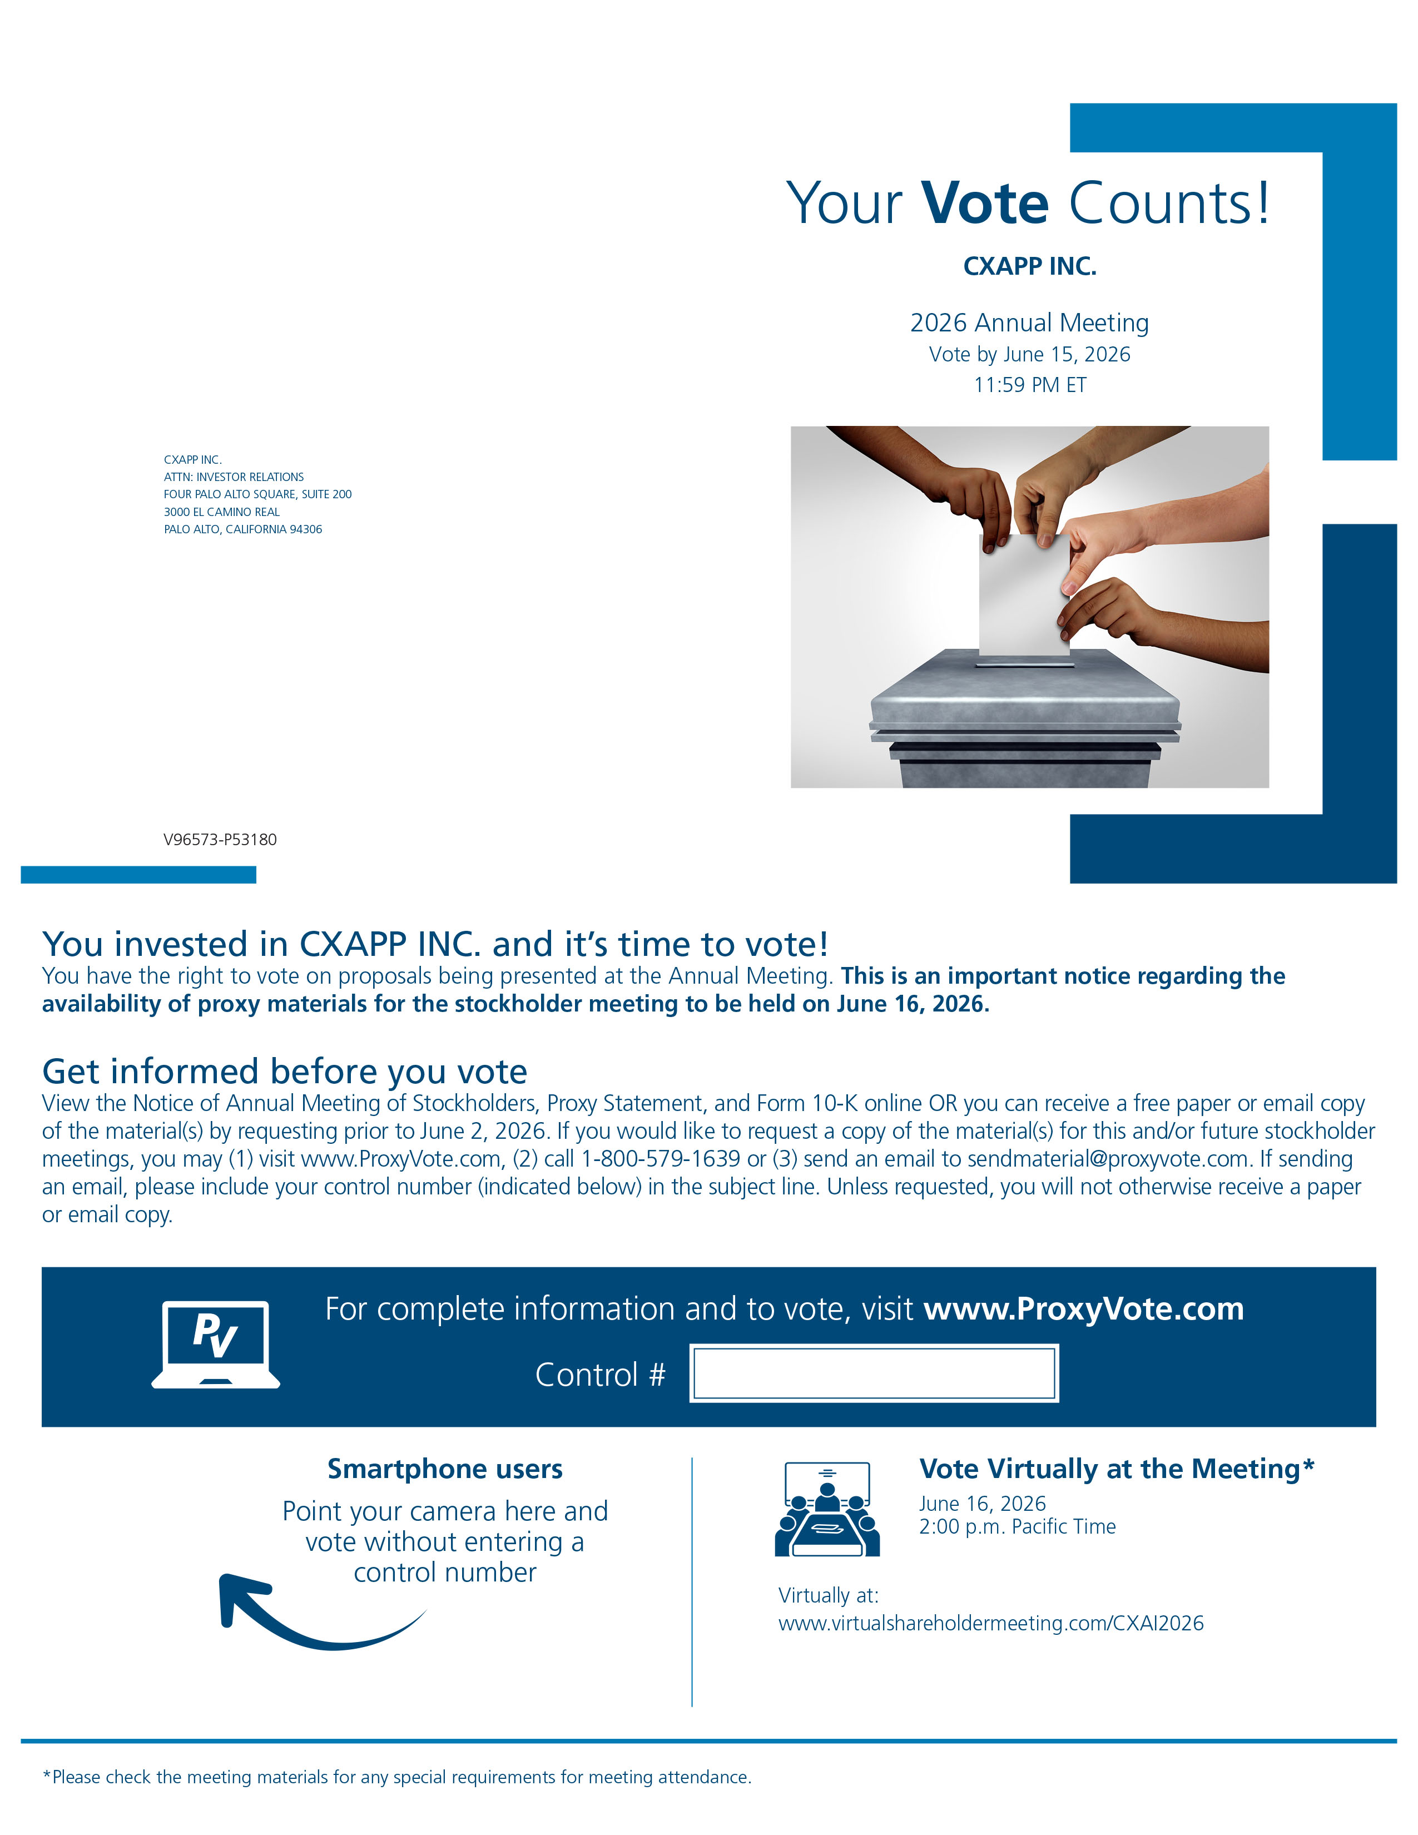
Your Vote Counts! Smartphone users Point your camera here and vote without entering a control number For complete information and to vote, visit www.ProxyVote.com Control # V96573 - P53180 CXAPP INC. ATTN: INVESTOR RELATIONS FOUR PALO ALTO SQUARE, SUITE 200 3000 EL CAMINO REAL PALO ALTO, CALIFORNIA 94306 CXAPP INC. 2026 Annual Meeting Vote by June 15, 2026 11:59 PM ET You invested in CXAPP INC. and it’s time to vote! You have the right to vote on proposals being presented at the Annual Meeting. This is an important notice regarding the availability of proxy materials for the stockholder meeting to be held on June 16, 2026. Get informed before you vote View the Notice of Annual Meeting of Stockholders, Proxy Statement, and Form 10 - K online OR you can receive a free paper or email copy of the material(s) by requesting prior to June 2, 2026. If you would like to request a copy of the material(s) for this and/or future stockholder meetings, you may (1) visit www.ProxyVote.com , (2) call 1 - 800 - 579 - 1639 or (3) send an email to sendmaterial@proxyvote.com . If sending an email, please include your control number (indicated below) in the subject line. Unless requested, you will not otherwise receive a paper or email copy. Vote Virtually at the Meeting* June 16, 2026 2:00 p.m. Pacific Time Virtually at: www.virtualshareholdermeeting.com/CXAI2026 *Please check the meeting materials for any special requirements for meeting attendance.

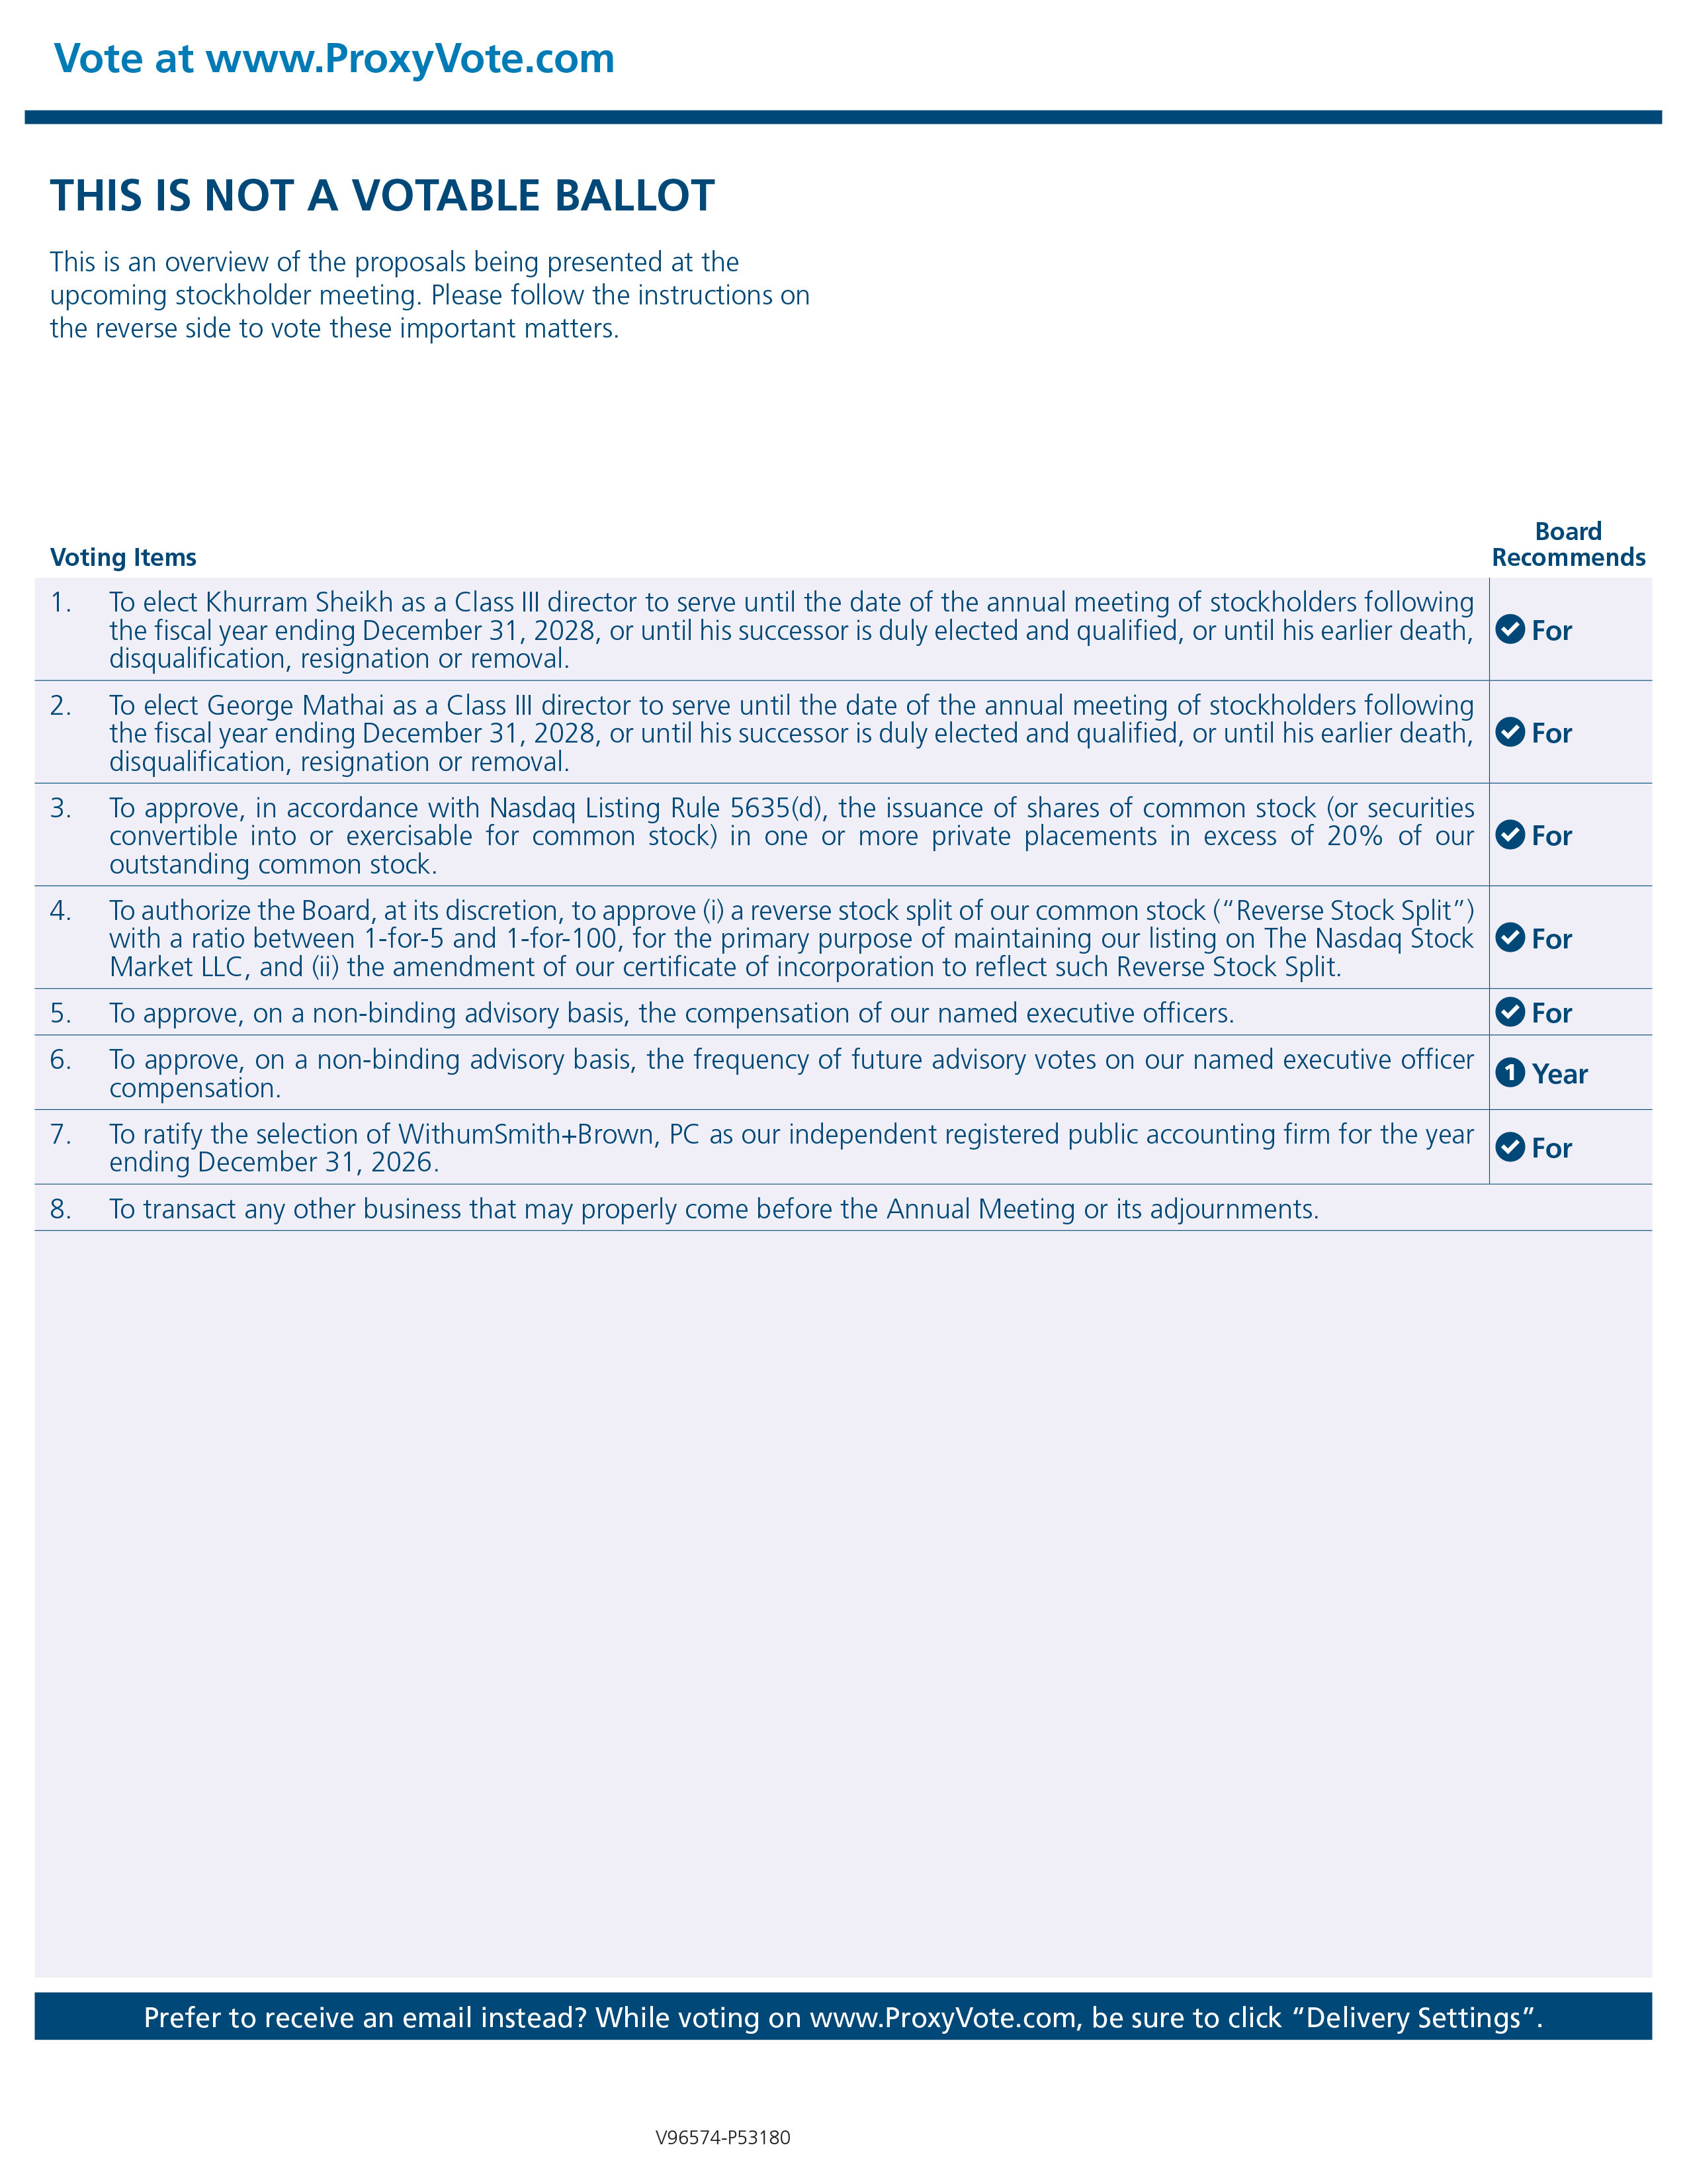
Vote at www.ProxyVote.com THIS IS NOT A VOTABLE BALLOT This is an overview of the proposals being presented at the upcoming stockholder meeting. Please follow the instructions on the reverse side to vote these important matters. Prefer to receive an email instead? While voting on www.ProxyVote.com , be sure to click “Delivery Settings”. For 1 . To elect Khurram Sheikh as a Class III director to serve until the date of the annual meeting of stockholders following the fiscal year ending December 31 , 2028 , or until his successor is duly elected and qualified, or until his earlier death, disqualification, resignation or removal . For 2 . To elect George Mathai as a Class III director to serve until the date of the annual meeting of stockholders following the fiscal year ending December 31 , 2028 , or until his successor is duly elected and qualified, or until his earlier death, disqualification, resignation or removal . For 3 . To approve, in accordance with Nasdaq Listing Rule 5635 (d), the issuance of shares of common stock (or securities convertible into or exercisable for common stock) in one or more private placements in excess of 20 % of our outstanding common stock . For 4 . To authorize the Board, at its discretion, to approve (i) a reverse stock split of our common stock (“Reverse Stock Split”) with a ratio between 1 - for - 5 and 1 - for - 100 , for the primary purpose of maintaining our listing on The Nasdaq Stock Market LLC, and (ii) the amendment of our certificate of incorporation to reflect such Reverse Stock Split . For 5. To approve, on a non - binding advisory basis, the compensation of our named executive officers. 1 Year 6. To approve, on a non - binding advisory basis, the frequency of future advisory votes on our named executive officer compensation. For 7. To ratify the selection of WithumSmith+Brown, PC as our independent registered public accounting firm for the year ending December 31, 2026. 8. To transact any other business that may properly come before the Annual Meeting or its adjournments. Voting Items Board Recommends V96574 - P53180

